===== 3rd Improvement proposed: Applying the progressive disclosure design pattern to the "Patron search" UI =====

=== The problem ===

The "Patron search" UI shows an unnecessary amount of features. Therefore this UI becomes very cluttered and complex which can produce confusion to the users and can make the application more difficult to learn, ending up in degradation of the user experience.

=== Patron search UI analysis ===

The "Patron search" UI is cluttered at the very beginning of any user flow, as you can see in the image below:

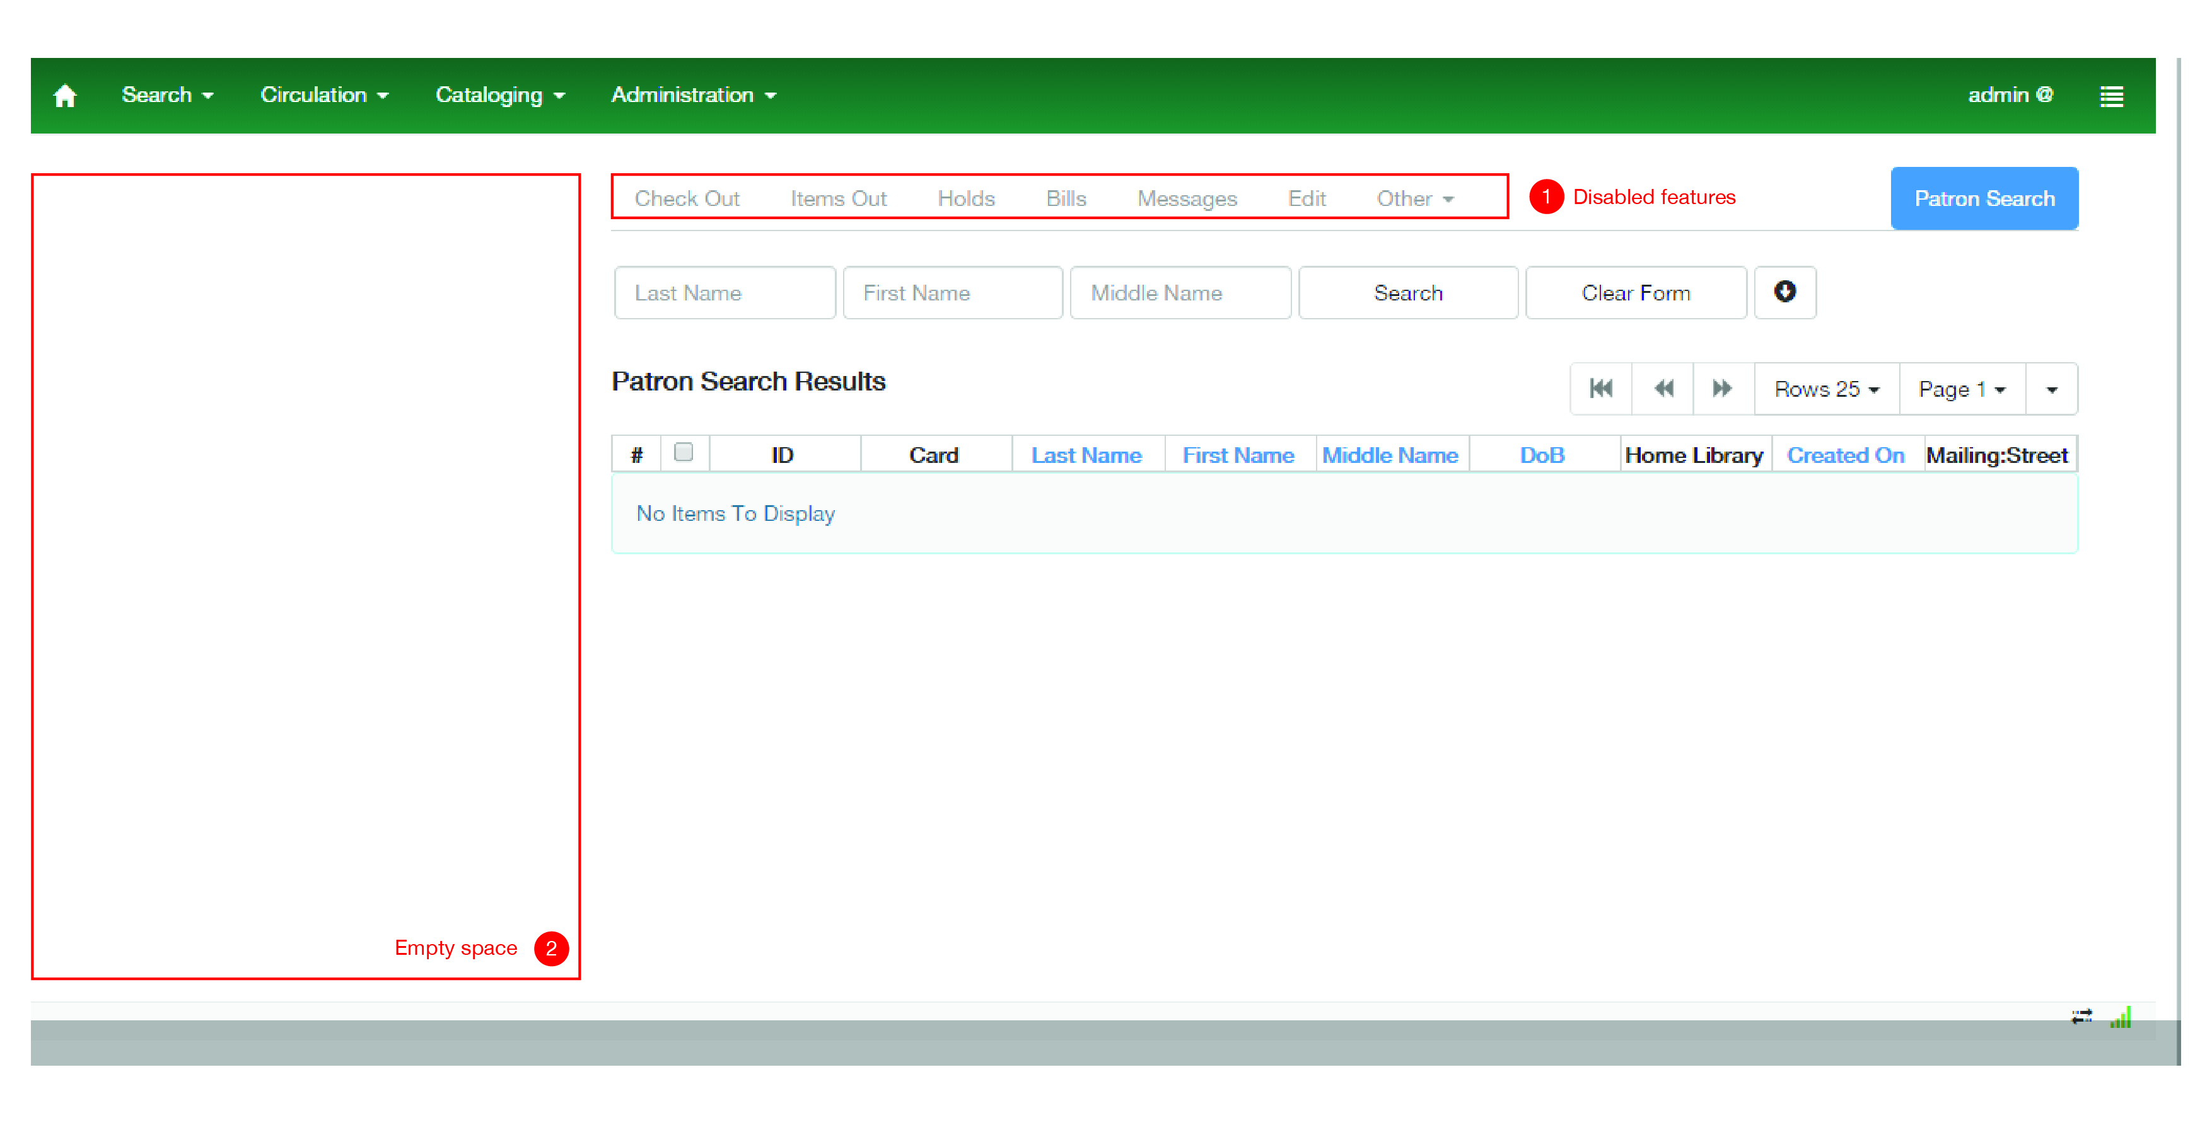

Regarding the points highlighted in the image, it is clear that there is unnecessary complexity added to the UI:

\* Disabled features (1): There is an entire disable menu showed to the user. This means that the UI is showing the user features that may be available in the future. A better approach would be to show this features when they are available in order to maintain the UI simple and to keep the user focused on the main task which is search for a patron.

\* Empty space (2): There is an empty space at the left of the search patron UI. This is actually saving space for the patron information but at this point the UI appears to be left aligned causing the loss of visual consistency. A better approach would be to show the patron information on demand, this is to say, when needed for the user.

=== Progressive disclosure design pattern ===

For UI problems of this kind, where it's wanted a very powerful interface, with many features, but it's also wanted to keep the interface as simple as possible, one of the best approaches is to apply the progressive disclosure design pattern.

Progressive disclosure is an interaction design technique often used in human computer interaction to help maintain the focus of a user's attention by reducing clutter, confusion, and cognitive workload. This improves usability by presenting only the minimum data required for the task at hand by sequencing information and actions across several steps in order to reduce feelings of being overwhelmed for the user. By disclosing information progressively, you reveal only the essentials and help the user manage the complexity of feature-rich applications. Progressive disclosure follows the typical notion of moving from "abstract to specific"; only it may mean sequencing interactions and not necessarily level of detail (information). In other words, progressive disclosure is not just about displaying abstract then specific information, but rather about 'ramping up' the user from simple to more complex actions.

The great designer Jakob Nielsen describes the progressive disclosure pattern with two simple steps:

\* Initially, show users only a few of the most important options.

\* Offer a larger set of specialized options upon request. Disclose these secondary features only if a user asks for them, meaning that most users can proceed with their tasks without worrying about this added complexity.

In its most formal definition, progressive disclosure means "to move complex and less frequently used options out of the main user interface and into secondary screens".

=== My proposal ===

There are several ways to apply the progresive disclousure pattern in a UI. Based on the actual "Patron search" UI I consider that the best approach is to use the dynamically-growing UI technique. By applying this approach the UI will progresive discover the features to the user by expanding itself. This approach has the following benefits:

\* The users can form a correct mental model of the task quickly and easy.

\* There are none of the awkward context switches that separate screens impose.

\* Since the UI is kept together on one page, the user can very easily go back and change their mind about earlier choices;

\* The users immediately see the effect on subsequent steps.

Below I show a couple of images with my proposed designs:

[IMAGE]

[IMAGE]

[IMAGE]

=== References ===

  \* <http://www.nngroup.com/articles/progressive-disclosure/>

  \* <http://www.time-tripper.com/uipatterns/Progressive_Disclosure>

  \* <http://sixrevisions.com/user-interface/progressive-disclosure-in-user-interfaces/>

  \* <http://experience.sap.com/basics/post-63/>

  \* <http://www.smashingmagazine.com/2009/06/23/10-ui-design-patterns-you-should-be-paying-attention-to/>

  \* <http://blog.teamtreehouse.com/read-more-about-progressive-disclosure>

  \* <http://en.wikipedia.org/wiki/Progressive_disclosure>